Penelope it's delicious

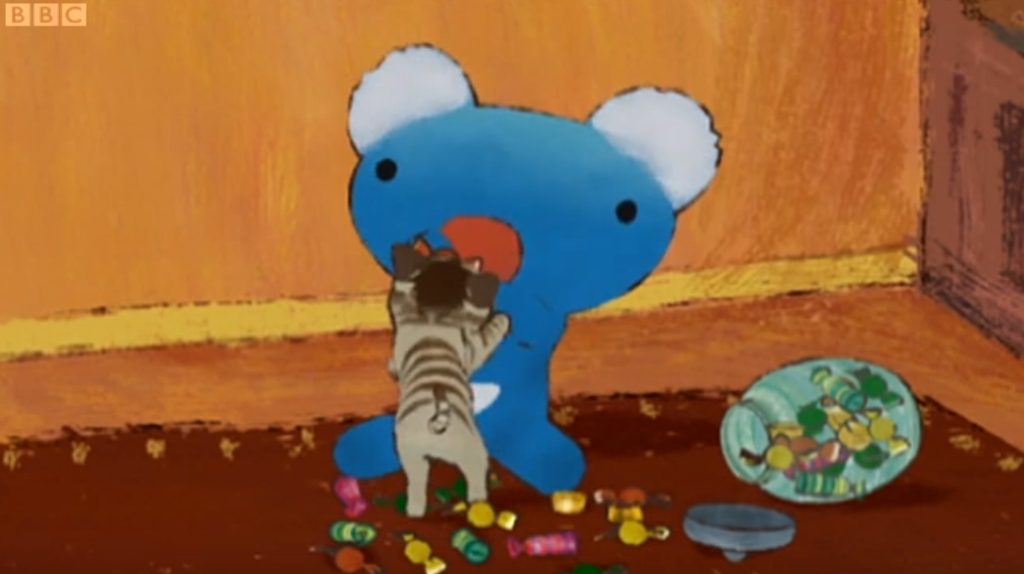

Nearly...

What is Penelope doing?

Oops. Which one should I try?

Maybe this chocolate,or I'll have this sweet.

Well, aren't you going to have dinner soon, Penelope?

Are you allowed to eat sweets before dinner?

What do you think?

Oh.

Penelope, dinner is ready.

But dad, I'm going to have a sweet now.

If you eat that sweet now, you won't be able to eat your dinner.

That's right.

If you eat sweet before dinner, you'll be too full to enjoy your meal.

Now, come sit at the table.

Oh, well.

Let's eat.

What are they having dinner for today?

This is nice.

You love cheese quiche , don't you, Penelope?

Yes, I love cheese quiche. But this soup...

But you haven't even tried the soup yet?

No...

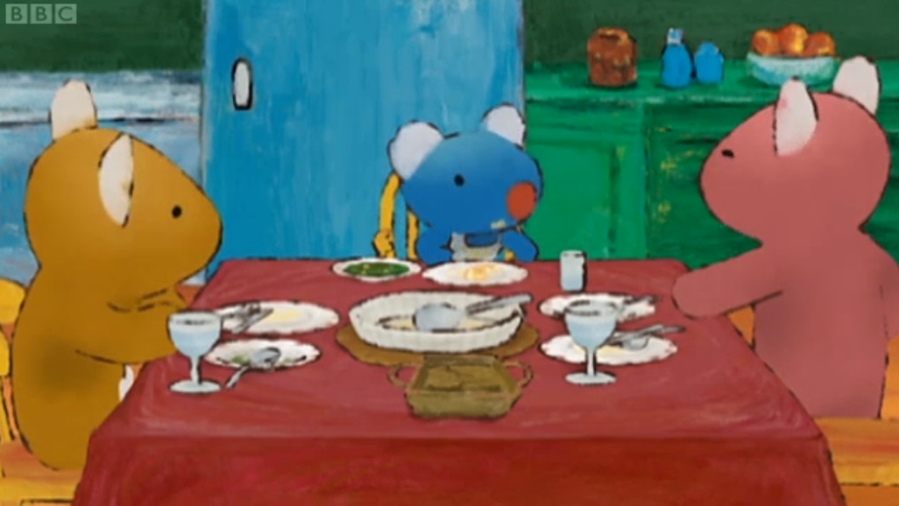

Penelope doesn't seem to like the soup.

Is that anything you don't like eating?

Ah, I!m full.

I hope you'll not too full for dessert.

Dessert? What are we having, Mum?

I made yummy custard.

Wow, custard,custard. I love custard.

Don’t get so excited, you’ll fall off the chair.

I love,love custard.

You can have custard when you finish the soup.

Oh, no.

Oh, dear, there's still a lot left.

But I can’t eat it, I’m full.

But if I don’t eat it ,I can’t have any custard.

Uh, yes, heehee

What if I swop my bowl with Dad’s .

Maybe he won’t notice.

Or maybe...

What if I give the soup to the hungry cat, then I can eat the pudding .

That’s a great idea.

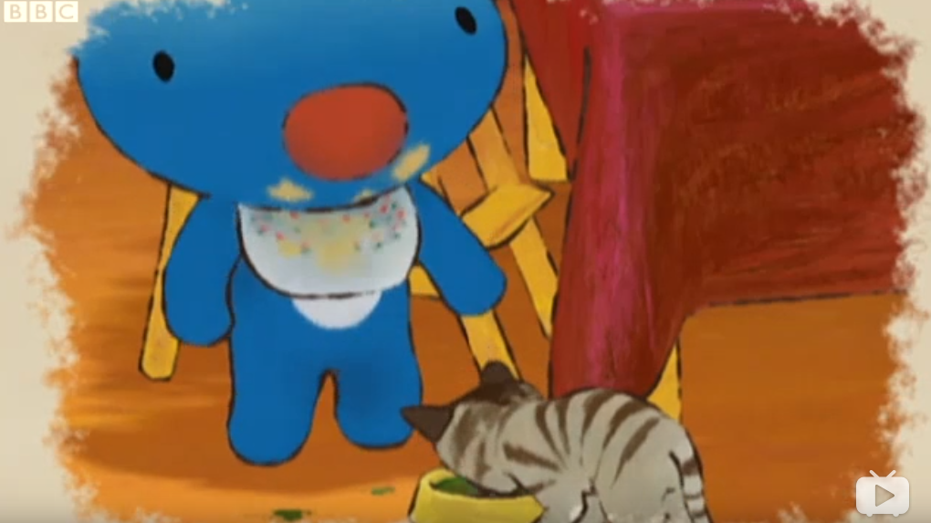

Come here. Come on.

Penelope

Penelope,What’s the matter?

You see, I’ve had a great idea.

A great idea?What is it?

La la la....

Why don’t you tell us?

It’s a secret.

What a cheeky girl she is!

You should have the soup your mother made for you, penelope.

Come on, Penelope.

Here, I’ll help you.

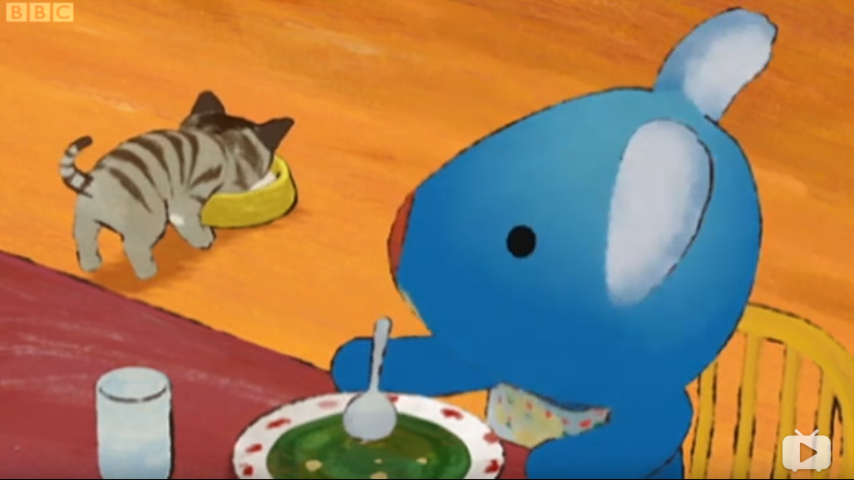

Ok. You’re very lucky,kitty.

She only has to eat what she likes.

Well, I'm sorry your plan didn’t work out,but don’t be disappointed. Your dessert is waiting for you, as soon as you finish your meal,Penelope.